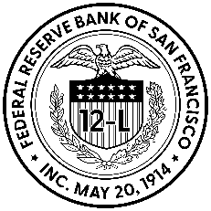
Borrower-In-Custody (BIC) Program
Collateral Transmittal & Custody Receipt for
Pledge of Credit Card Receivables (Form CCR-1)

To the Federal Reserve Bank of San Francisco:

(Financial Institution) < INSERT NAME > with ABA# <INSERT ABA> , hereafter referred to as Financial Institution, pledges Credit Card Receivables to secure advances under provision of the Federal Reserve Act.

Total current balance of credit card receivables pledged:
Replaces prior pledged in the amount of:
As of Date:
Description of range of account numbers pledged:
Collateral Location and/or Third-Party Custodian Location
FRB Use Only: | Approved by:
FRB Use Only: | Processed by:

I certify that the receivables summarized above:
- are in the control and custody of the pledging institution and/or pledging entity/third party custodian(s),
- are not receivables granted to individuals residing &/or entities incorporated outside the United States of America and, that the depository institution has rights in the collateral referenced in this schedule and its title to such collateral is free of any adverse claim, lien, security interest and restriction on transfer or pledge and held subject to the order of the Federal Reserve Bank of San Francisco pursuant to the terms of Operating Circular 10.

This Collateral Transmittal and Custody Receipt are a part of the Letter of Agreement for Operating Circular 10 referred to above.
<MO/DD/YR> | <INSERT NAME & TITLE> | ______________________________
Date | Print Name and Title | OC-10 Authorized Signer
<MO/DD/YR> | <INSERT NAME & TITLE> | ______________________________
Date | Print Name and Title | OC-10 Authorized Signer

As defined under FFIEC Call Report Code 6a.
As required by your Form of Authorizing Resolutions for Borrowers, one or two person(s) previously identified by us must sign the CCR-1. CCR-1 (6/2025)

